**CAT-2 Revision Questions (Set-1)**

1. Consider the below 8-Puzzle game tree. Assume the goal node.

i.Find out a good heuristic function to evaluate the values of each node.

ii. Draw a tree for four levels. Determine the value of the game by applying alpha beta pruning with proper illustration. Leaf node value is the heuristic function value.

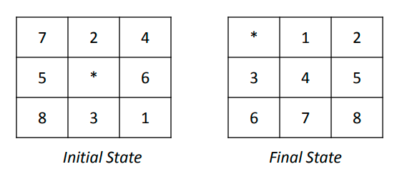

Answer:

H1: Number of misplaced tiles. since it is clear that every tile that is out of position must be moved at least once.

h1 = 8.

H2: Sum of Manhattan distances of the tiles from their goal positions

H2 = 3 + 1 + 2 + 2 + 2 + 3 + 3 + 2 = 18

H3: Number of tiles out of row + Number of tiles out of column

H3 = 5 (out of row) + 8 (out of column) = 13.

2. Calculate the value at the root of the tree using minimax algorithm.

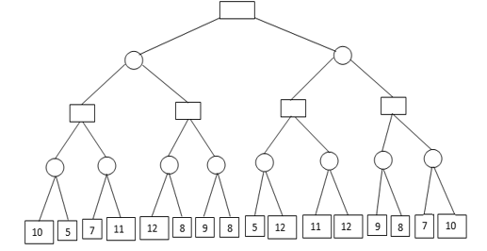

3. The 4-queens problem consists of a 4 x 4 chessboard with 4 queens. The goal is to place the 4 queens on the chessboard such that no two queens can attack each other. Each queen attacks anything in the same row, in the same column, or in the same diagonal. The image below gives initial position of the board. By applying efficient heuristic function (number of pairs of queens attacking each other, directly or indirectly) generate game search tree. Solve the problem by using hill climbing approach. Check whether this problem will struck in the local maximum, plateau or ridge. Discuss how to resolve this problem using hill climbing strategy

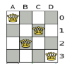

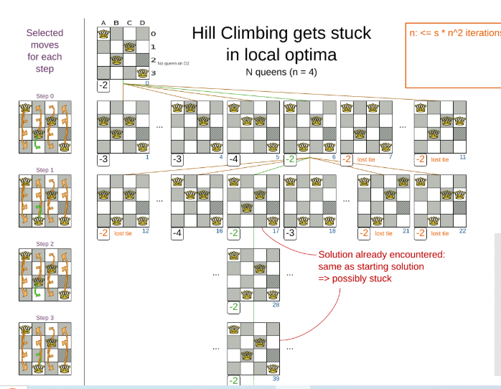

4. In the given tree ‘ S’ is the starting node and ‘G’ is the goal state find the optimum path using local search approach.

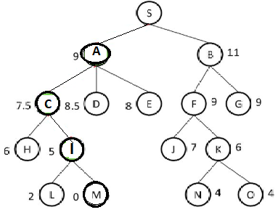

5. Consider the following facts.

1. Team India
2. Team West Indies
3. Semi-Final match between India and West Indies.
4. India scored 250 runs, West Indies scored 250 runs, India lost 5 wickets, West Indies lost 7 wickets.
5. The team which scored the maximum run Wins.
6. If the scores are same, the team which lost minimum wickets win the match.

Represent the facts in

1. Predicate logic, Convert to clause form

ü. Prove by resolution India wins the match".

1. Team(India)
2. Team(WestIndies)
3. Semi-Final-Match(India,WestIndies)
4. Score(India,250)
5. Score(WestIndies,250)
6. WicketsLost(India,5)

7. WicketsLost(WestIndies,7)

8. ∀X,Y,R1,R2(Score(X,R1)∧Score(Y,R2)∧R1>R2)→Win(X)

9. ∀X,Y,R,W1,W2(Score(X,R)∧Score(Y,R)∧WicketsLost(X,W1)∧WicketsLost(Y,W2)∧W1<W2)→Win(X)

CNF Conversion

8. ¬Score(X,R1)∨¬Score(Y,R2)∨¬(R1>R2)∨Win(X)

9. ¬Score(X,R)∨¬Score(Y,R)∨¬WicketsLost(X,W1)∨¬WicketsLost(Y,W2)∨¬(W1<W2)∨Win(X)

#### ****Step 3.2: Convert to CNF (Clause Form)****

1. Team(India)
2. Team(WestIndies)
3. Match(India,WestIndies)
4. Score(India,250)
5. Score(WestIndies,250)
6. WicketsLost(India,5)
7. WicketsLost(WestIndies,7)
8. ¬Score(X,R1)∨¬Score(Y,R2)∨¬(R1>R2)∨Win(X)
9. ¬Score(X,R)∨¬Score(Y,R)∨¬WicketsLost(X,W1)∨¬WicketsLost(Y,W2)∨¬(W1<W2)∨Win(X)

6. The Traveling Salesman Problem (TSP) is a well-known example for optimization problem. The goal is to determine the quickest path between the starting city and a given set of cities. Local search algorithm can help for the TSP work by starting with an initial solution and incrementally improving (minimize the distance) it by making small changes to it one at a time until no more advancements are possible. Using simulated annealing algorithm solve the given problem. Initial temperature is 37. Initial tour is A → C → B → D → E → A. Successor function is swap two cities randomly to generate a new tour. Cooling factor is 20%. Repeat the process for five iterations and find the optimal solution.

|  |  |  |  |  |  |
| --- | --- | --- | --- | --- | --- |
|  | A | B | C | D | E |
| A | 0 | 7 | 4 | 6 | 8 |
| B | 7 | 0 | 10 | 8 | 7 |
| C | 4 | 10 | 0 | 5 | 5 |
| D | 6 | 8 | 5 | 0 | 9 |
| E | 8 | 7 | 5 | 9 | 0 |

1. Convert the following sentences into propositional logic.
2. It is not cloudy and it is not raining.
3. Sam likes to eat strawberry and peach.
4. Behind the mountain the sun is shining.
5. If a function is differentiable then the function is continuous.
6. John will study for the final exam otherwise he will fail.
7. John can access the internet in the college only if he is computer science student or not a fresher.
8. Convert the following sentences into conjunctive normal form.
9. (P → (Q → R)) → (P → (R → Q))
10. (P → Q) → ((Q → R) → (P → R))
11. ((A → B) → C) V (A → (B → C))
12. (P→R)∨(Q→R)

(P →Q)→((Q→R)→(P →R))

Answer: ¬(¬P ∨Q)∨(¬(¬Q∨R)∨(¬P ∨R))

(P ∧¬Q)∨((Q∧¬R)∨(¬P ∨R))

(P ∧¬Q)∨((Q∨¬P ∨R)∧(¬R∨¬P ∨R))

(P ∧¬Q)∨Q∨¬P ∨R

(P ∨¬P ∨Q∨R)∧(¬P ∨Q∨¬Q∨R)

True